

**EE464**

**STATIC POWER CONVERSION-II**

**Term Project Final Report**

**Group Isolated**

***Contributors***

Büşra Nur KOÇAK 1929355

Defne Nur KORKMAZ 2166858

Mustafa Mert Sarıkaya 2094381

Table of Contents

Introduction 3

Project Description 4

Topology Selection 4

Forward Converter 4

Flyback Converter 5

Analytical Calculations 6

Transformer Calculations 6

Skin Effect 6

Ferrite Core Calculations 6

Iron Powder Core Calculations 9

Core Selection 9

Selecting Turns and Wire Size 10

Core Type Selection 12

Component Power Calculations 12

Component Selection 15

Thermal Analysis 16

Cost Analysis 18

Simulations 19

Power Losses 23

Ferrite Core Transformer Power Losses 23

Iron Powder Core Transformer Power Losses 23

Core Losses 23

Copper Losses 24

Mosfet power Loss 24

Diode Loss 24

Snubber Loss 24

PCB Design 25

Conclusion 31

# Introduction

The aim of this project is to provide the transformation that will convert the high voltage power supply output suitable for the low voltage range devices. Therefore, the study is about to reduce the input voltage ranging from 220V to 400V for the Tesla Model S’s equipment that needs 12V input voltage. Since one of the most important requirements of the project was to provide an isolated system design, the topology types used in the given operating ranges, which will allow isolated converter design, were examined. Afterwards, the controller was selected according to the selected topology and the frequency range, duty cycle and turns ratio values to be operated were determined. With the completion of the transformer design and component selections in accordance with the simulation results taken from the selected controller, the theoretical calculations and the power loss calculations of the system have been completed.

# Project Description

In this project, we are asked to design an isolated DC/DC converter in order to convert 220-400VDC input voltage to 12VDC with 100W output power. The specifications and requirement for the projects are following:

* Minimum Input Voltage: 220 V
* Maximum Input Voltage: 400 V
* Output Voltage: 12 V
* Output Power: 100 W
* Output Voltage Peak-to-Peak Ripple: 4%
* Line Regulation: 3%
* Load Regulation: 3%

# Topology Selection

## Forward Converter

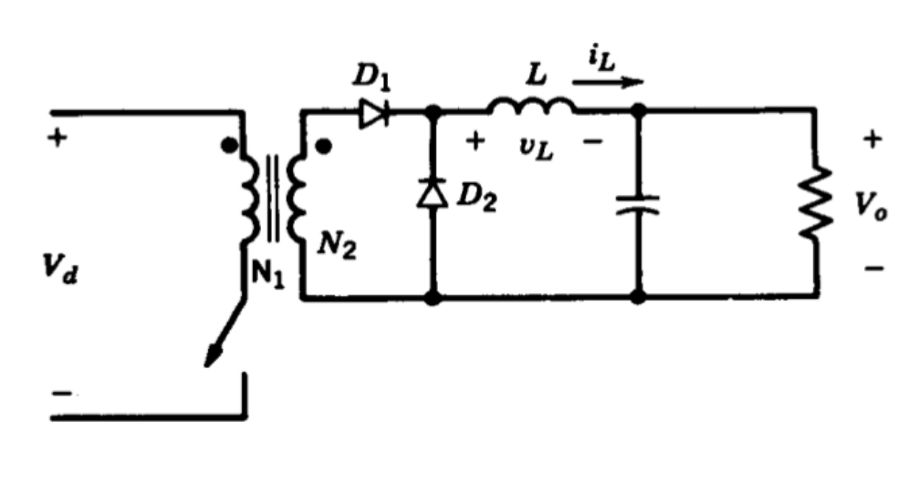

Figure 1: Forward Converter Topology

**Advantages:**

* Allows smaller transformer design than a flyback converter
* Better at isolated high-power applications
* Switching device has less voltage stress across it
* Low power losses and noise
* Does not require any snubber circuit

**Disadvantages:**

* The transformer core must be freed from unintentionally stored energy with each cycle
* Requires additional inductor at the output side
* More expensive
* Harder to control

## Flyback Converter

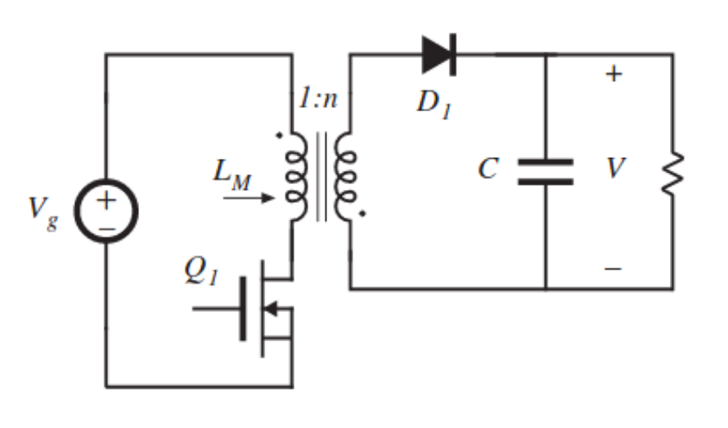

Figure 2: Flyback Converter Topology

**Advantages:**

* Better utilization of transformer
* Output inductor and diode ensure continuous output current
* More efficient to filter out high-frequency components
* Easier to control
* DCM operation allows soft switching
  + Allows to use smaller transformer core
  + Reduce switching losses

**Disadvantages:**

* Higher voltage stress across the MOSFET
* Gain changes a lot in DCM operation

Forward and Flyback converter topologies have been considered and examined in detailed while deciding on the topology which will be used in the project. According to the advantages and disadvantages of the both topologies, it has been decided to work on the Flyback converter design. While making the topology selection, some of the important factors have been evaluated as providing easier control of the converter and finding isolated controller options that meets the project requirements. In addition to these, the difficulty of controlling the forward converter and the possibility of causing problems in cases where the energy on the transformer could not be discharged regularly, made it certain to prefer the flyback converter topology.

# Analytical Calculations

## Transformer Calculations

In an isolated flyback converter design, the core selection completely depends on the operating frequencies. As the operating frequency increases, maximum flux density created will decrease; therefore, increasing operating frequency is an advantage to prevent saturation in the core and also helps to use smaller core structure with increased efficiency. Smaller transformer core also helps to decrease the cost and size of the converter with a considerable amount. Therefore, the calculations of the transformer have been conducted considering 100kHz operating frequency, even though it will be adjusted by the flyback controller itself.

Moreover, operating region is also an important factor while deciding the size of the transformer core, where DCM operation allows to design smaller transformers by limiting flux density in the core and prevents from the saturation problems. Therefore, DCM operation has been assumed to be used in the design while calculating transformer values and dwell time duty ratio () is assumed to be 0.1.

In the first transformer design of the process, ferrite cores with an additional gap will be considered using Kg method, which allows to calculate required air gap, fringing losses and the cable losses in the transformer design. Moreover, this method allows to count the required strands number for the Litz wire design according to the selected core properties.

## Skin Effect

Operating frequency of the transformer is a primary property while deciding the cable size, which will be used during the design. Increasing operating frequency will cause current to flow from more outer part of the cable. Therefore, the middle part of the cable will be useless in the conduction period and this will cause increase in the resistance values. Considering this relationship between the frequency and cable size, it is preferred to design the transformer cables as Litz wire with multiple strands by calculating the number of layers which should be used for primary and secondary sides. Considering this perspective, calculating the skin depth for 100kHz gave an important clue while deciding the size of the cable which will be layered.

|  |  |  |
| --- | --- | --- |
|  |  | [1] |

According to the calculation done in the [1], it had been decided to use #26 AWG wire as base wire while designing the Litz wire size and number of layer requirements.

## Ferrite Core Calculations

The first specification which should be considered while designing the transformer for flyback converter is that the energy storage capability of the core. Therefore, the inductance needed for the storage of a specific amount of energy storage is also important.

|  |  |  |
| --- | --- | --- |
|  |  | [2] |

As the name suggest value, which is a core geometry values includes both energy requirements of the transformer application. Therefore, this value has been calculated first to decide the limiting value for the power handling capacities of the core selection.

|  |  |  |
| --- | --- | --- |
|  |  | [3] |

Considering both the value, saturation conditions of the ferrite cores, window area, permeability and inductance value per , EE-21 core have been chosen to be the core of the transformer design to continue with the calculations.

Table 1. Design data for EE ferrite cores

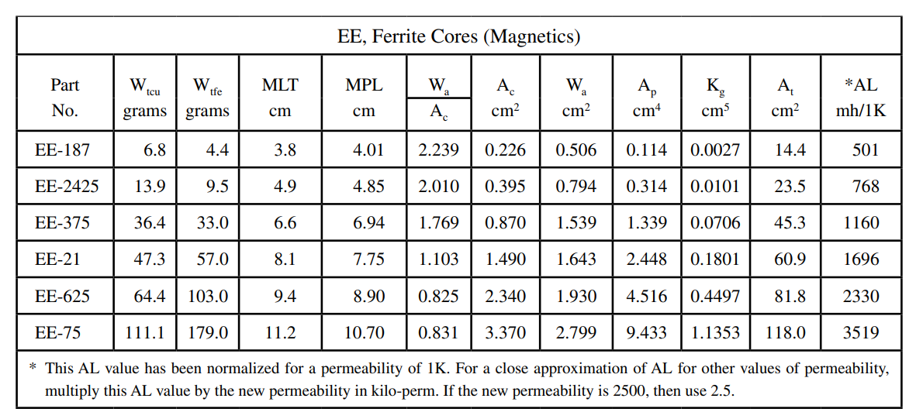

Before getting into the core calculations, the peak and rms values of the primary current have been calculated for the future calculations considering both current density in the core and strands numbers required for the transformer design.

|  |  |  |
| --- | --- | --- |
|  |  | [4] |

Moreover, the values of the selected core structure have been used to calculate the current density, wire area in the core, required number of strands and number of turns with the Equations [5], [6], [7], [8].

|  |  |  |
| --- | --- | --- |
|  |  | [5] |

: Maximum flux density, [T]

: Area Product, []

: Window utilization, 0.29

|  |  |  |
| --- | --- | --- |
|  |  | [6] |

: Primary wire area

|  |  |  |
| --- | --- | --- |
|  |  | [7] |

: Required number of primary strands

|  |  |  |
| --- | --- | --- |
|  |  | [8] |

: Window area of the core

: Number of primary turns

Because of the high permeability values of the ferrite cores, storing the required energy in the core requires some additional gap. Calculation of the additional gap for storing previously specified energy value can be observed from Equation [9].

|  |  |  |
| --- | --- | --- |
|  |  | [9] |

: Iron area

: Magnetic path length

: Permeability of the core material

It should be also considered that even though adding a gap to increase the energy storage capability of the ferrite core is a preferred method at some cases, it has some disadvantages as fringing flux. Therefore, this effect should be also calculated to consider its effect on the power loss of the transformer design.

|  |  |  |
| --- | --- | --- |
|  |  | [10] |

Moreover, the fringing flux also has an effect on the number of required turns in the primary side of the transformer and the peak flux density as follows.

|  |  |  |
| --- | --- | --- |
|  |  | [11] |

: New number of turns for the primary

|  |  |  |
| --- | --- | --- |
|  |  | [12] |

: Magnetic path length

As the number of turn and strands values of the primary have been completed, ESR resistance of this side can be also determined by considering both the designed Litz wire strands, #26 AWG copper wire resistance property, number of turns in the primary and the magnetic path length of the selected core.

|  |  |  |
| --- | --- | --- |
|  |  | [13] |

Moreover, secondary side of the transformer can be calculated with the values, which have been calculated so far. Decided duty cycle and dwell time duty ratio plays an important role while calculating the secondary side of the transformer. Moreover, the voltage drop on the output part of the flyback converter is assumed to be 1V during the calculations.

|  |  |  |
| --- | --- | --- |
|  |  | [14] |

Other than the turn number of the secondary of the transformer, same calculations have been applied to calculate secondary peak current, rms current, wire area, secondary strands number, and winding resistance.

|  |  |  |  |  |
| --- | --- | --- | --- | --- |
| Turns ratio | (mutual inductance) | (primary strands) | (secondary strands) | (window utilization) |
| 6 | 80µH | 9 | 67 | 0.1 |

## Iron Powder Core Calculations

### Core Selection

The iron powder core selection for flyback converter design is based on the energy storage. Therefore, it is important to calculated the amount of energy where the core should reach in the time. This can be calculated using the peak current and inductance of the primary.

|  |  |  |
| --- | --- | --- |
|  |  | [15] |

= Output Power (Watts) = 100 W

= Minimum input voltage (Volts) = 220 V

= Maximum duty cycle = = 0.35

= Switching frequency (kHz) = 100 kHz

The primary inductance can be calculated using the primary peak voltage as Equation 16:

|  |  |  |
| --- | --- | --- |
|  |  | [16] |

By using calculation, a core selection can be made according to the energy desired to be stored.

|  |  |  |
| --- | --- | --- |
|  |  | [17] |

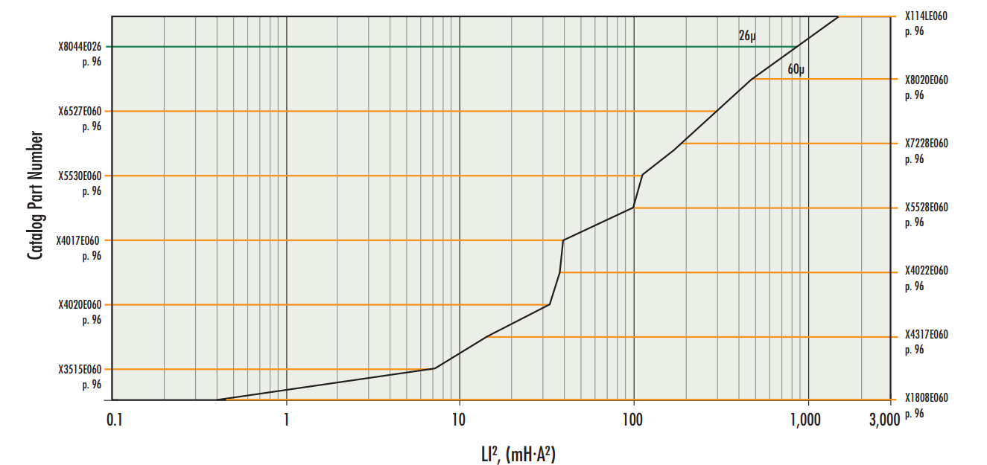

Figure 3: XFlux E Core enery storage table

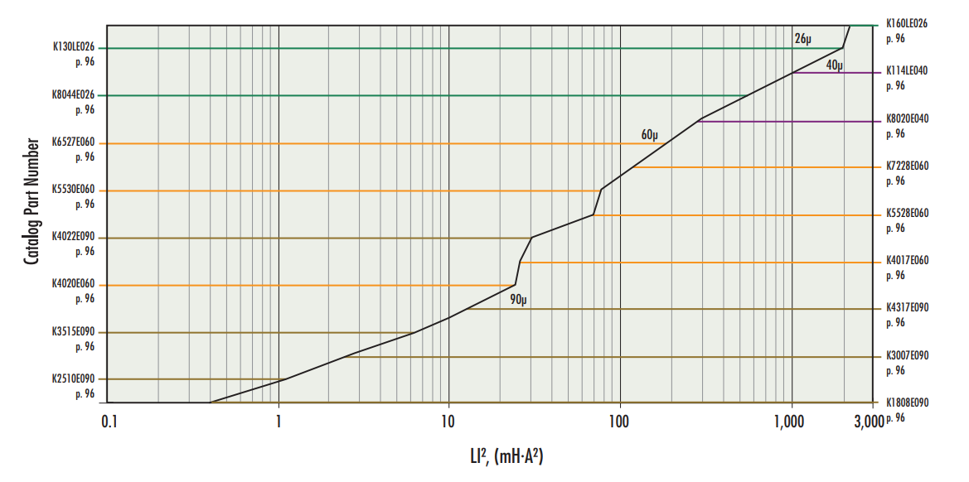

Figure 4: Kool Mµ E Core enery storage table

According to the energy storage tables of XFlux and Kool Mµ E cores (Figure 3 and 4), it is deemed appropriate to use K3007E90 core for smaller transformer design where it allows around 2.5 mH*A2 energy.

### Selecting Turns and Wire Size

Calculation of the primary inductance and choosing the material type allow to design the turns of the wires with respect to the core data. Kool Mµ cores have different permeability chooses, where 90µ has been considered to prevent too much copper losses by decreasing the turn number with an increased permeability. The selected core for the selected permeability have inductance of . Therefore, number of primary turns can be calculated as Equation 18, which is proposed by the Magnetics.

|  |  |  |
| --- | --- | --- |
|  |  | [18] |

|  |  |  |
| --- | --- | --- |
|  |  | [19] |

= Output voltage (V)

= Diode voltage drop (V-> taken to be 1V)

Moreover, average voltage of the primary side of the transformer should be known to determine the cable thickness needed.

|  |  |  |
| --- | --- | --- |
|  |  | [20] |

Due to the high frequency where the transformer is expected to operate, cable selection should be made according to the skin effect.

|  |  |  |
| --- | --- | --- |
|  |  | [21] |

=Skin depth

=Resistivity of the Material

= (Relative Permeability) *(Permeability Constant)

If the selected cable is greater than the skin depth, current will flow only around the cable, not in the middle. Therefore, the cable selection has been done considering skin depth value to decrease amount of the AC losses. For this reason, AWG 26 cable has been selected due to its diameter. On the other hand, AWG 26 cable is capable of transmitting 0.361 A current. Therefore, paralleling 2 cables in the primary and 12 cables in the secondary has been deemed appropriate.

Another value to be checked after the cable selection is the core utilization value, where it shows if the cables fit inside the core window and how much space do they take up.

|  |  |  |
| --- | --- | --- |
|  |  | [22] |

, = Number of parallel cables in the primary and secondary

= Winding area of the bobbin which will used in the E core (PCB3007T1)

## Core Type Selection

According to the ferrite core calculations with air gap and iron powder core calculation with distributed air gap, it has been observed that the transformer design made with iron powder is more advantageous. The difficulty in designing and producing the air gap obtained during ferrite core design, its lower saturation flux density value compared to iron powder cores, and its inconvenience for small transformer design are some of the main reasons for choosing iron powder core. In addition to all these, the window area of the smaller sized iron powder core was used more efficiently than the ferrite core. Since the design of a small converter was aimed at the beginning of the project, the smaller size of the core and the efficient use of the core window area were considered as important factors, and therefore the ferrite core was not seemed to be sufficient.

## Component Power Calculations

Specifications of project are

Vin(min) =220 V,

Vin(max) =400V,

Pout =100W,

Vout=12V

We have to decide some values for calculation and to get smaller transformer and ripples we decide switch frequency as 100khz. Our system will operate in Discontinuous conduction mode and we decide dwell time as one over ten period time. Also, maximum duty ratio as taken 0.2. Our secondary side diode will operate at high current so we can’t just assume its on voltage as zero volt, before deciding diode we take diode on voltage as 1V. Transformer won’t operate at 100% efficiency and before designing that we assume efficiency as 90%. So decided values are as given.

fS = 100kHz

Ddwell = 0.1

Dmax= 0.35 at 220V and Dmin = 0.1925 at 400V

Vdiode = 1 V

ɳtransformer = 0.9

Primary and Secondary powers

By using output power and output voltage, average output current calculated. Then diodes power dissipation added and secondary sides total power calculated. Transformer is not ideal and we choose efficiency as 90% percent and primary sides power calculated with including core loss.

Iout(avg)= Pout / Vout = 8.33 A

Pdiode = Vdiode x Iout(avg) = 8.33 W

Psecondary = Pdiode + Pout = 108.33 W

Pprimary = Psecondary / ɳtransformer = 120.37 W

Primary and secondary sides peak current:

Primary and secondary sides inductor current is triangular shape and its peak value calculated with the following equations.

For 220 volt source voltage:

Iin(avg) = Pprimary / Vin(min) = 0.547 A

Iin(peak) = 2 x ( Iin(avg) / Dmax) = 3.12 A

For 400 volt source voltage:

Iin(avg) = Pprimary / Vin(max)  = 0.30 A

Iin(peak) = 2 x ( Iin(avg) / Dmin) = 3.12 A

Isecondary(peak) = 2 x (Iout(avg) / (1 - Dmax - Ddwell)) = 30.30 A

Ratings of Components

Transformer, Mosfet, Diode and Output Capacitor are important components for flyback converter, Transformer’s calculation showed in previous part and turn ratio taken as 6. Mosfet, Diode and Output Capacitors required ratings analytically calculated in following equations.

Nturn = 6

For Mosfet:

VDS(max) = Vin(max) + (Vout x Nturn) = 497.71 V

IDS(peak) = Iin(peak) = 3.12 A

For Diode:

VD(max) = Vout(max) + (Vin(max) / Nturn) = 78.67 V

ID(max) = Isecondary(peak) = 30.30 A

Output Capacitor:

At the output 2 capacitor parallely connected. Single ones values 330 uF - 13 mΩ so net values 660 uF – 6.5 mΩ.

∆Vout(max) = Vout x (3/100) = 0.36 V

IC(pp) =(Iout(avg) x (1+ ((Dmax + Ddwell) / (1 - Dmax - Ddwell))) = 15.15 A

∆VESR = ESR x IC(pp) = 0.0985 V

∆QC = Iout(avg) x (Dmax + Ddwell) / fS = 3.75x10-5 C

∆VC  = ∆QC / Cout = 56.8 mV

∆Vout = ∆VESR + ∆VC  = 0.1553 V

# Component Selection

In the previous part, we have decided the required component values with the LTSpice simulation tool and calculations. To provide a reliable design, we considered the inrush currents and surge voltages. Therefore, we have chosen our components by considering the maximum power rating and its tolerance. Also, in order to decrease the final size of the design, we tried to choose the component in small packages.

At first, we have decided on the controller. We have needed a flyback controller which provides 100W power and around 100kHz frequency range to decrease the size of the transformer. Also, to make the simulation part easier, we looked for the Analog Design Manufacturer. In the end we have decided on the LT8316 controller.

Then, we looked for the semiconductor components which are MOSFET as a switch, diodes for the secondary side of the converter and for biasing of the controller. As a mosfet, we have decided on IPAN70R450P7S. Its ratings are given in Table 2.

Table 2. Mosfet Ratings

|  |  |
| --- | --- |
| **Parameter** | **Value - Description** |
| VDS , Breakdown voltage | 700V |
| ID, Continuous current | 10A at TC =20 oC |
| ID,pulse Pulsed Drain current | 25.9 A |
| RDS,ON | 450mΩ |
| Qg | 13.1nC |
| Price | $ 0.69 |

Then, the diode of the secondary side is chosen as MBR40250G which provides 40A continuous current and 80A repetitive current.

Table 3. Diode Ratings

|  |  |
| --- | --- |
| **Parameter** | **Value - Description** |
| VR , Blocking voltage | 250V |
| IRMS, Continuous current | 40A |
| IFRM, Peak Repetitive Forward Current | 80A |
| VF | 0.86V |
| Price | $1.0178 |

The biasing diode is chosen as to provide 5A continuous and 8A surge current. Also, it needs a small forward voltage. For this purpose, we have decided on BAS3010A03WE6327HTSA1 diode.

Then, we have worked on the capacitors and resistors in the circuit. The most important capacitor is output capacitor and the most important resistor is sense resistor. The output capacitor is chosen as it represents low ESR value and appropriate capacitance and voltage rating. Therefore, it is chosen as 337ULR016MFF. 2 capacitors placed at parallel to decrease ESR and increase the capacitance.

Table 4. Output Capacitor Ratings

|  |  |
| --- | --- |
| **Parameter** | **Value - Description** |
| C, Capacitance | 330uF |
| VC,MAX Rating | 16V |
| IC,ripple | 4.3A |
| ESR | 13mΩ |
| Price | $0.2925 x 2 |

The sense resistor should be in small resistance value and should handle the power that will flow through it. Therefore, it is chosen as WK73S2ATTDR10J which is 100mΩ and 1W power rating resistor.

The other capacitors and resistors are chosen according to their voltage value on the simulation. The important thing is here, they are chosen the smallest package in the required ranges.

# Thermal Analysis

Transformer

Temperature Rise of the transformer can be calculated using the total power loss by the formula given in the site of the Magnetics as follows:

Mosfet

Pmos,tot  = Pconduction + Pswitching = 0.8442 W

For normal conditions, let choose ambient temperature as 25oC.

If no heatsink applied, the junction temperature is:

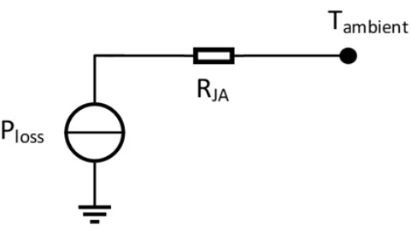

Tjunction = Tambient +PlossRJA = (25 + 0.8442 * 80) = 92.54oC

Our mosfet can operate in this temperature and even if its current rating decrease, it is still can supply maximum input current when it is on. So, heat sink is not used for mosfet.

Diode

PDiode,tot  = Pconduction + Pswitching = 7.17W

For normal conditions, let choose ambient temperature as 25oC.

If no heatsink applied, the junction temperature is:



Tjunction = Tambient +PlossRJA = (25 + 7.17* 50) = 383.5oC

As seen in the result, diode dissipate high energy and heatsink has to used for diode to operate in its temperature region.

For heat sink HSE-B20380-040H-01 selected and its specialty seen in the graphs.

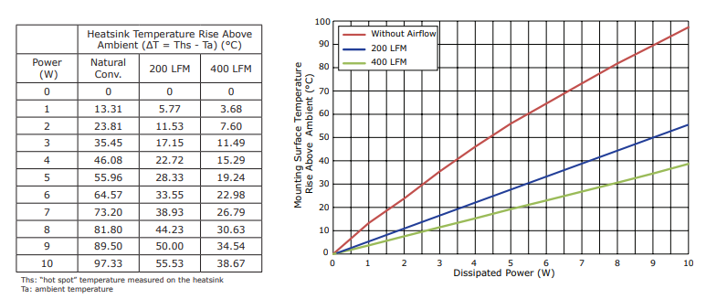

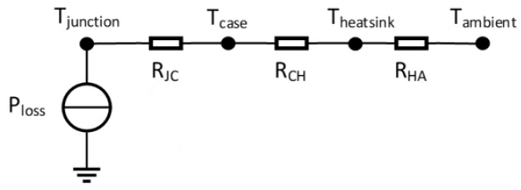

Tjunction = Tambient +∆Theatsink + PlossRJC = (25 + 81.8 + 7.17*2) = 121.14oC

Resulting temperature is not low but diode can operate at this temperature. Since our peek current is not close to the maximum ratings decrease in the max current ratings at the high temperature don’t affect the converter.

# Cost Analysis

|  |  |
| --- | --- |
| **Component** | **Price ($)** |
| K3007E90 core | 0.78 |
| B66232J1112T001 Bobbin | 0.82 |
| Copper Cable (11 m) | 2.25 |
| IPAN70R450P7S | 0.69 |
| MBR40250G | 1.0178 |
| 337ULR016MFF (x2) | 0.2925 x 2 |
| Resistors (1.5Mohm – 10Kohm) (x8) | 0.005 x 8 |
| 354010KFT Resistor | 0.468 |
| ERJ-3BWFR033V Resistor | 0.0074 |
| ERJ-2LWJR010X Resistor | 0.045 |
| UVK105CG4R7JW-F Capacitor (x2) | 0.05 x 2 |
| 04026D105KAT4A Capacitor | 0.027 |
| 885012005078 Capacitor | 0.029 |
| TMK105BJ104MV-F Capacitor | 0.006 |
| BAS3010A03WE6327HTSA1 Diode | 0.125 |
| S5KCTR Diode | 0.0966 |
| HSE-B20380-040H-01 Heat Sink | 0.529 |
| PCB |  |
| **Total** | **7.619** |

# Simulations

After components selected their model implemented in LTspice and simulations test applied under 400V input voltage. Controller change its frequency at different conditions when 220 V applied switching frequency is 107 kHz and at 400 V its frequency become 130 kHz.

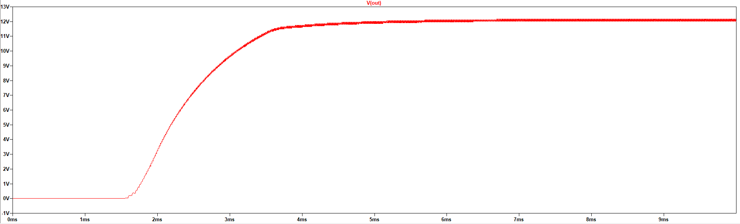

Figure 5: Output voltage waveform

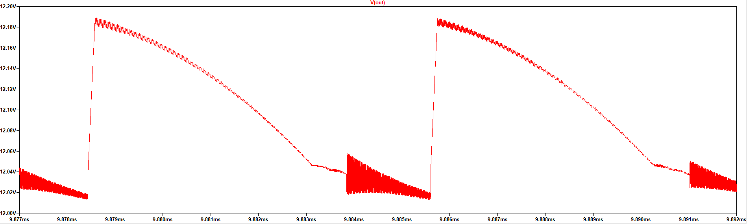

Figure 6: Output voltage close view waveform

As seen in the figure 5 after system turn on output voltage increase to the 12 V and give stable output voltage. Figure 6 shows ripple of output voltage and it is 0.17 V so output voltage ripple ratio is 1.417% and it is appropriate for project requirements.

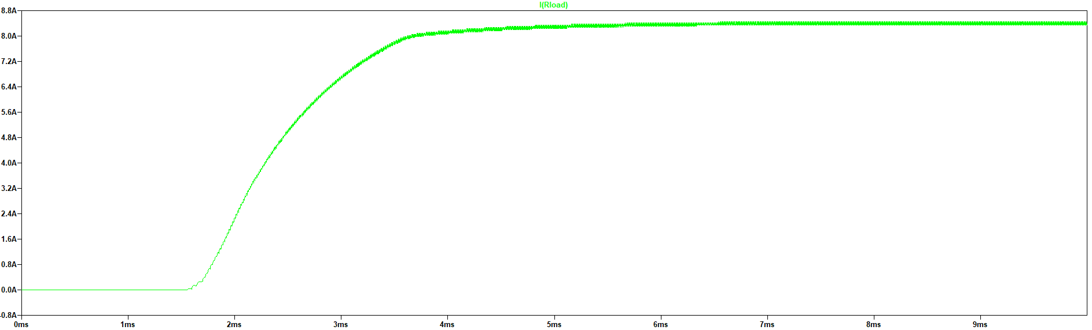

Figure 7: Output current waveform

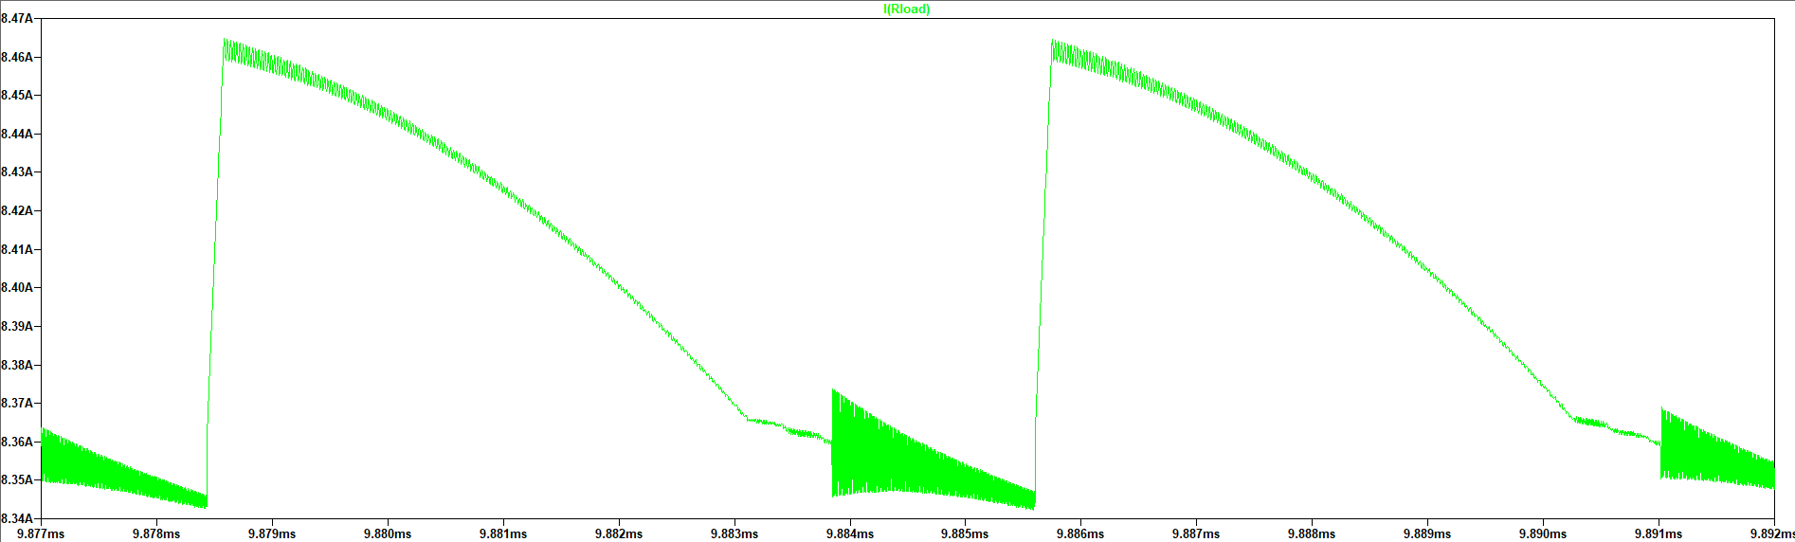

Figure 8: Output current close view waveform

In simulation tested load taken as fully resistive component and it is 1.44Ω so output current waveforms same as voltage and output power 101.7 W and it is little exceeding our rated power because voltage is little higher than 12V.

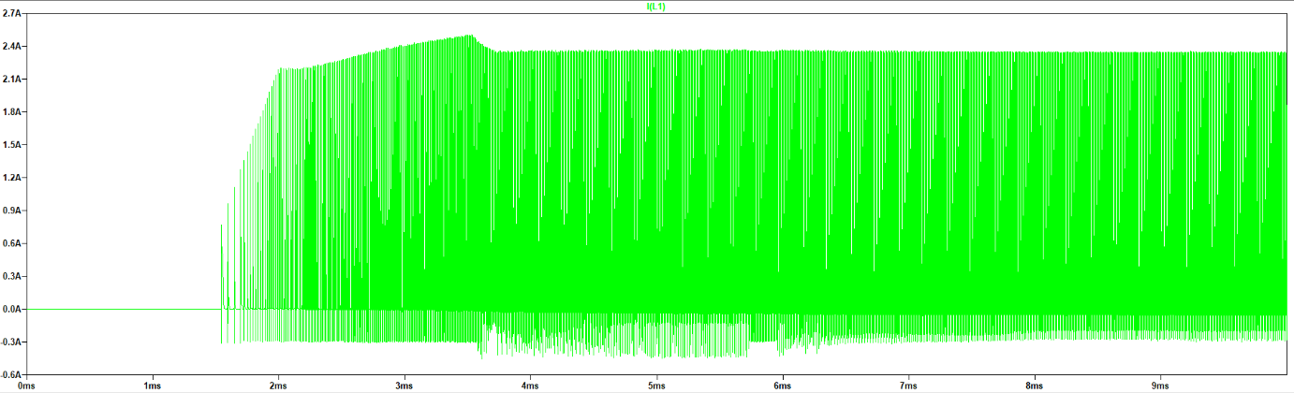

Figure 9: Primary inductor current waveform

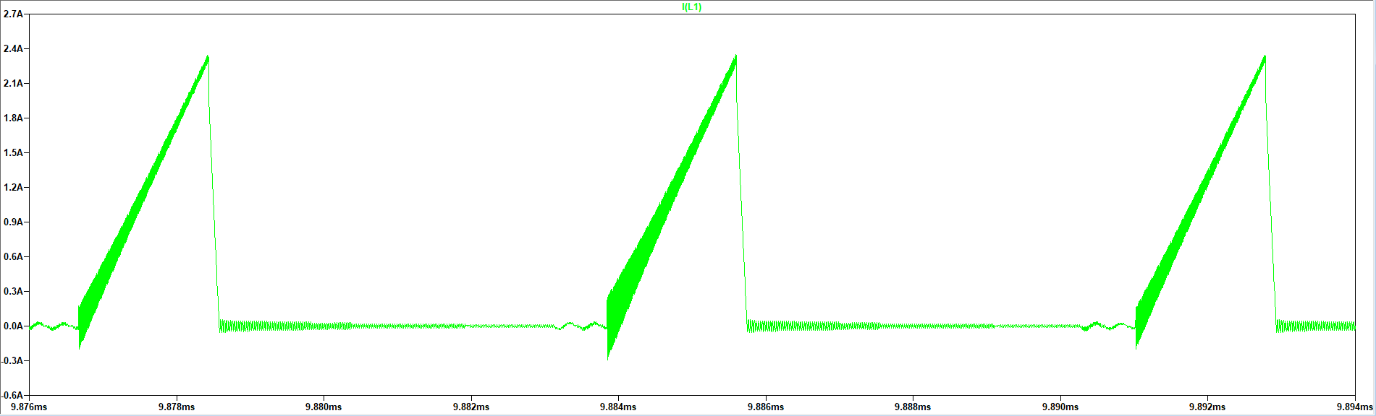

Figure 10: Primary inductor current close view waveform

When we look at the figure 9 its seen that initially current increase up to 2.5A then it is settled at 2.3A because initially output voltage is zero and system have to charge output capacitance and feedback system of the controller increase duty cycle and this result higher primary current. At figure 10 triangular shape of inductor current seen at mosfet on.

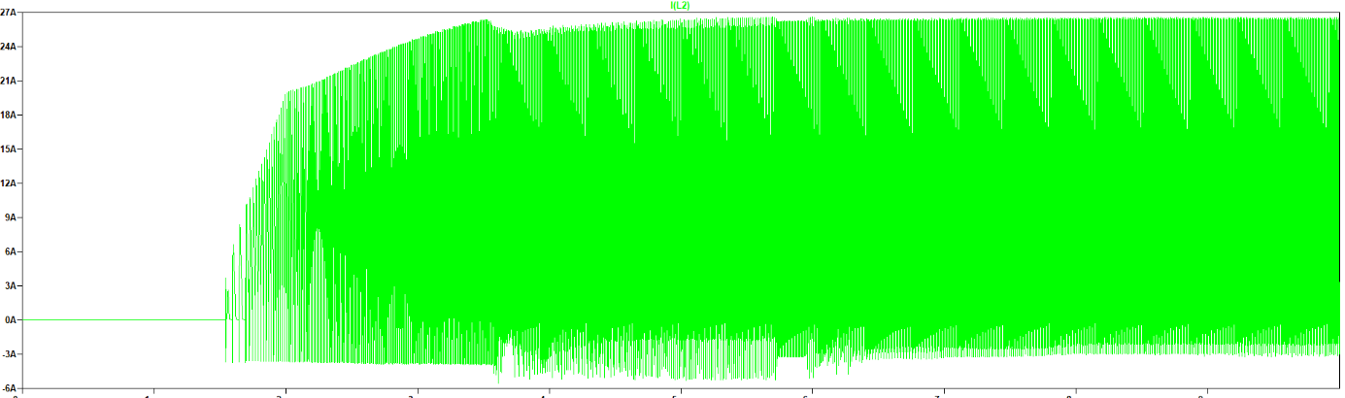

Figure 11: Secondary inductor current waveform

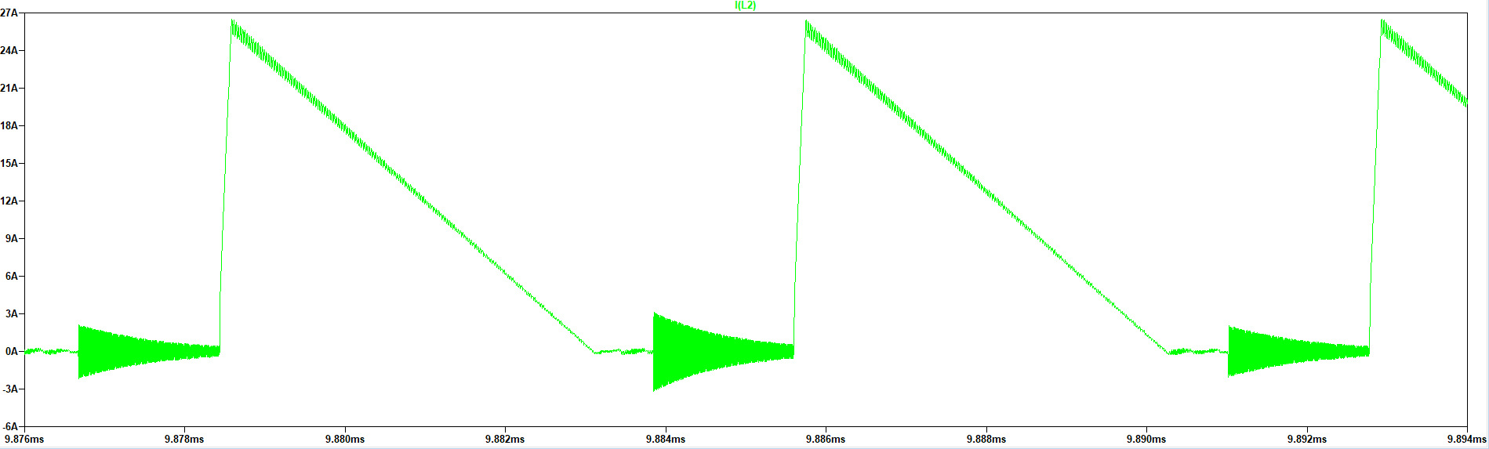

Figure 12: Secondary inductor current close view waveform

Secondary part of transformer has higher current density and its current reach 27 A since controller has soft start so its current does not increase much initially.

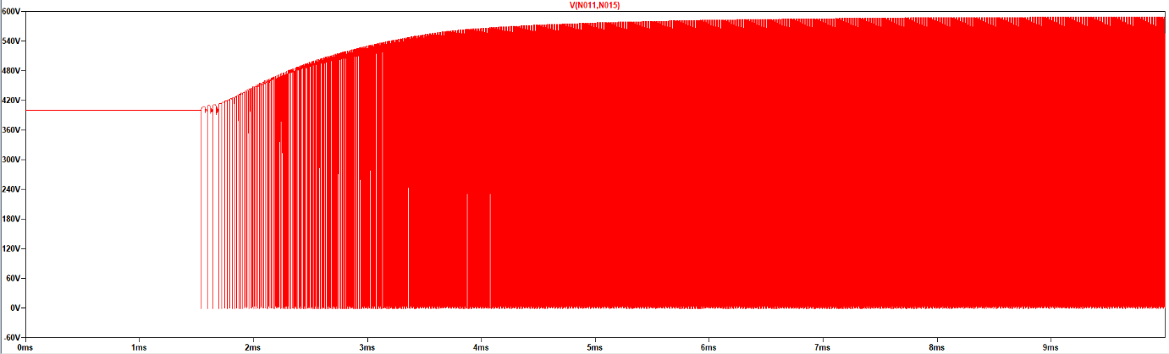

Figure 13: Mosfet voltage waveform

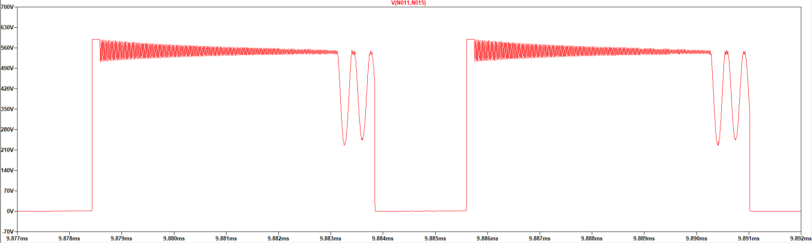

Figure 14: Mosfet voltage close view waveform

Selected mosfets breakdown voltage is 700 V and as seen in the figure 14 its voltage jumps to the 600V when it is turn of because of the leakage inductance. At Ddwell time its voltage oscillates. When looked at the figure 9 and 13 they’re in the our mosfets operation region.

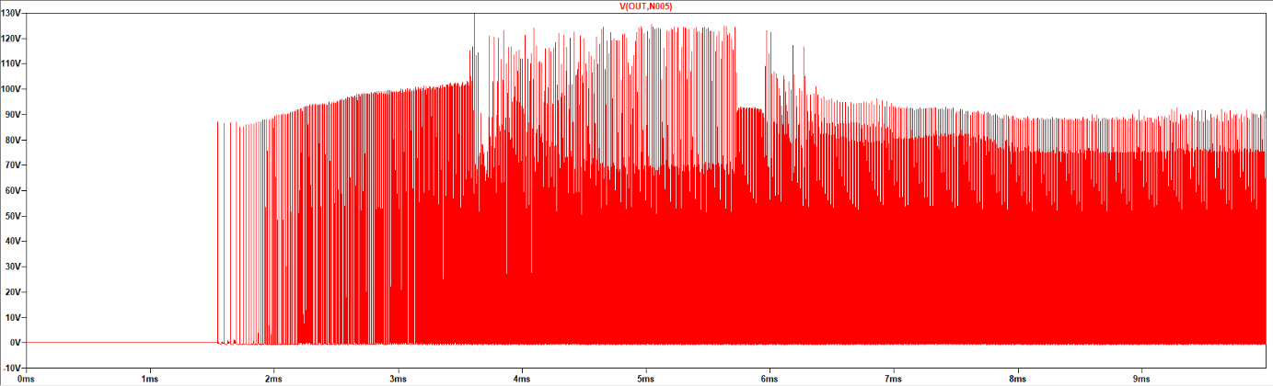

Figure 15: Diode voltage waveform

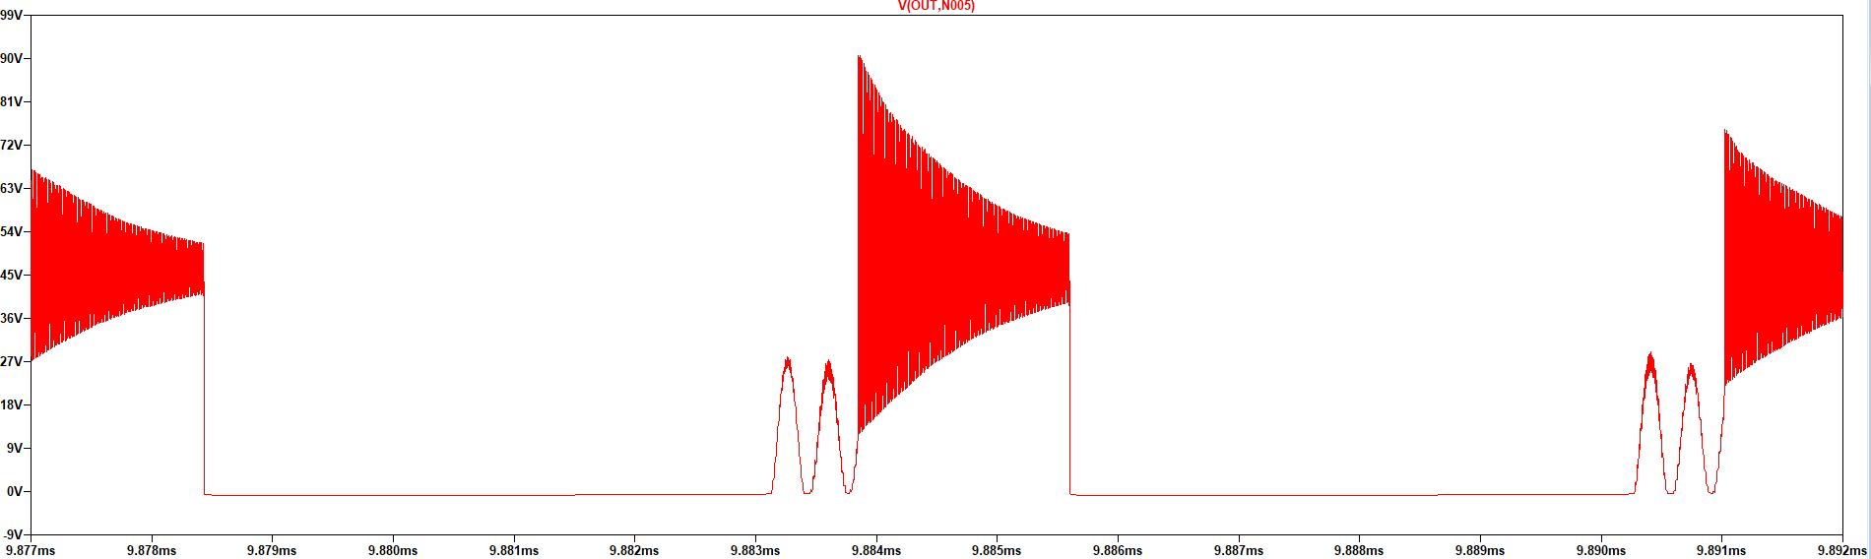

Figure 16: Diode voltage close view waveform

Selected diode breakdown voltage is 250 V and it can operate this voltage as seem in the figure 15 ratios. Diodes continuous current 40 A and as figure 11 shows secondary sides current reach 27 A and it is lower than continuous current .

# Power Losses

## Ferrite Core Transformer Power Losses

Ferrite Core Power Losses

Required length of wire have been calculated for both primary and secondary in the transformer calculations part. Moreover, required number of strands also considered in both sides. A third winding is also necessary similar with the secondary side of the transformer for carrying reference voltage to the feedback pin of the transformer. As the primary and secondary windings’ resistances and rms currents have been calculated before, their copper losses can also be calculated.

|  |  |  |
| --- | --- | --- |
|  |  | [23] |

In addition to the copper losses, there is also core losses exist due to fringing flux caused by the added gap in the ferrite core.

|  |  |  |
| --- | --- | --- |
|  |  | [24] |

: AC flux density

|  |  |  |
| --- | --- | --- |
|  |  | [25] |

: Watts per kilogram

|  |  |  |
| --- | --- | --- |
|  |  | [26] |

: Core loss

|  |  |  |
| --- | --- | --- |
|  |  | [27] |

: Total power loss

## Iron Powder Core Transformer Power Losses

### Core Losses

It is deemed appropriate to calculate core losses of the iron powder core using the peak current of the primary side by the Equation 28:

|  |  |  |
| --- | --- | --- |
|  |  | [28] |

This core loss calculation gives a value for the material time, but it should be recalculated using the core dimensions as Equation 29 shows:

|  |  |  |
| --- | --- | --- |
|  |  | [29] |

= the magnetic path length

= Cross sectional area of the core

### Copper Losses

Copper losses of the transformer design can be divided into two parts while on of them is DC losses, other one represents AC losses. Since the cable selection has been done considering the skin depth, the AC and DC resistances can be assumed to be almost the same.

= Resistance of the cable per meter

Therefore, the total loss of the transformer including core and copper losses considering the skin effect can be calculated as follows:

## Mosfet power Loss

According to the Equation [20] mosfet conduction loss is 0.0157W.

|  |  |  |
| --- | --- | --- |
|  |  | [30] |
|  |  |  |

According to the Equation [21] mosfet switching loss is 0.8285W.

|  |  |  |
| --- | --- | --- |
|  |  | [21] |
|  |  |  |

## Diode Loss

According to the Equation [22] diode conduction loss is 7.167 W.

|  |  |  |
| --- | --- | --- |
|  |  | [22] |

According to the Equation [23] diode switching loss is 0.0032W

|  |  |  |
| --- | --- | --- |
|  |  | [31] |

## Snubber Loss

According to the Equation [24] snubber loss is 4 W.

|  |  |
| --- | --- |
|  | [32] |

## PCB Design

After finalizing the simulation result and component selection, we moved into the PCB design. For this purpose, we have used Altium Designer software.

Previously, we had drawn the schematic library and footprints of the selected components for Simulation Report. Since the snubber and transformer design were not finalized, they were missing in the simulation report. The circuit schematic of the updated final design is given below.

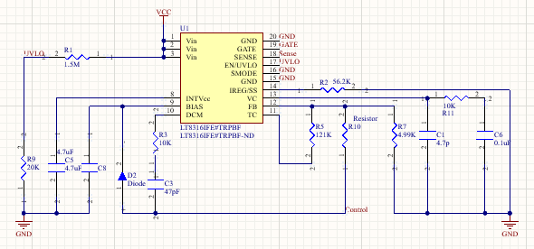

Figure 17: Schematic of the PCB

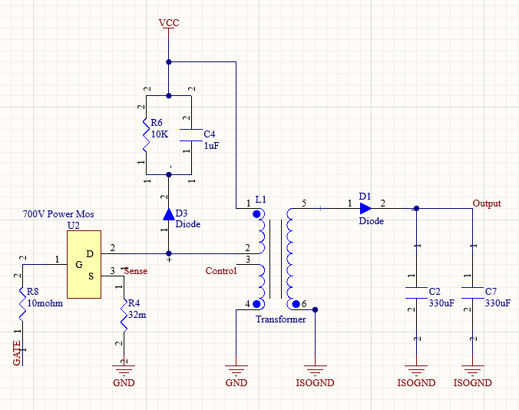

Figure 18: Schematic of the PCB

In the first picture, the controller and feedback part of the controller can be seen. In the second picture, the switching MOSFET, snubber unit (R6, C4, D3), transformer, output capacitor and diode can be seen. The second winding on the primary side represents the feedback of the controller. We have ensured the isolation with the ISOGND ground connection in the secondary side. According to this schematic, the PCB design is composed of 11 resistors, 6 capacitors, 3 diodes, 1 switching MOSFET, 1 transformer and 1 IC controller. In order to decrease the of the PCB, we have selected the components as small as possible.

After components selection, we have drawn the footprints of the component. In here, we have used the 3D bodies for the components except for the transformer. Since it is designed as custom, there is an extruded 3D body for the transformer according to its dimensions.

The overall view of the PCB is given below.

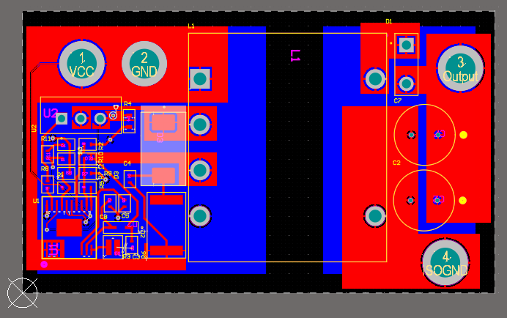

Figure 19. Overall PCB Design

We have used THD packaged component for diode, transformer, MOSFET, and output capacitors. Also, we have full fill the bottom part with ground and isolated ground polygons. Thus, we did not prefer place any components on the bottom part although we desire a compact design. The reason is avoiding from electromagnetic interference on the device by dividing the ground polygons.

For the input and output voltages, and ground connections, we have transmitted the power via polygons instead of thin tracks in order to avoid any damage of the high power density. Also, we have used polygons whereas the circuit geometry allows the range areas. The other tracks are made with 0.4mm width. The 2D top and bottom view of the PCB is given below.

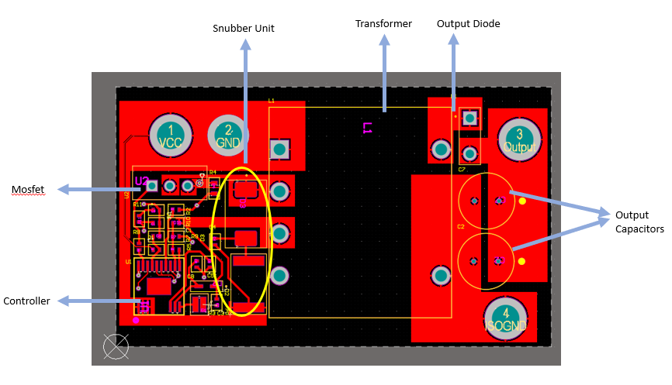

Figure 20. Top view of the PCB

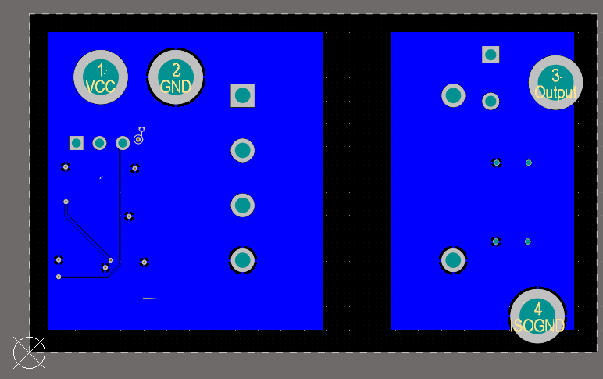

Figure 21. Bottom view of the PCB

In order to prevent violating the isolation, we have a gap between grounding of the primary and secondary side.

The size of the PCB card is 37mm*62mm in final. The height of the circuit depends on the transformer height, so it is 30mm. The leads of the THD components can be trimmed while the manufacturing. The 3D views are given in below.

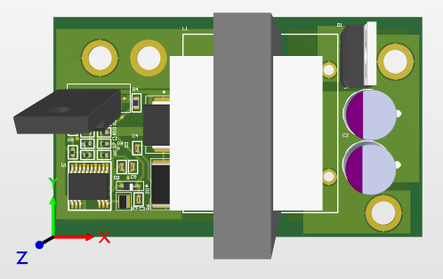

Figure 22. Top view of the PCB

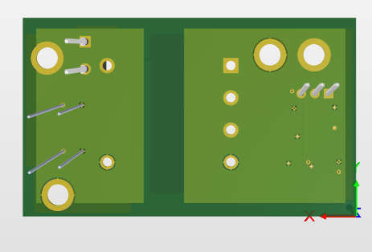

Figure 23. Bottom view of the PCB

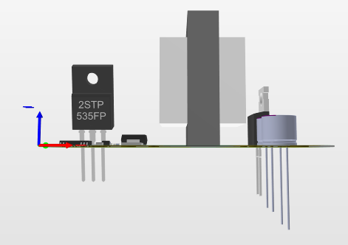

Figure 24. Side view of the PCB

# Conclusion

Within the scope of this project, it is aimed to create a circuit that will perform the voltage conversion operation between the high voltage battery and low voltage battery in Tesla Model S vehicles. Thanks to this transformation, the devices in the low voltage range (12V) will be operated by using 220V – 400V input voltage. Since the system has high input voltage and low output voltage value, an isolated structure has been specifically studied. For this reason, isolated converter topologies were examined one by one and their advantages and disadvantages were evaluated. Later, studies were carried out on the transformer design to be used in isolated power transmission. After determining the required duty cycle and turns ratio values, the system was simulated and the rated values of the required components were determined. Lastly, theoretical calculations have been completed with component selection and power loss calculations.